**How to operate on MKS TFT with filament sensor.**

**1.when it is on printing**

**pause-----more-----change----in/out-----stop**

**2.before printing**

**set-----change-----preheat-----in/out-----stop**

1).Plug filament sensor on MKS TFT PB1.(Please check photo1)

   The printer will auto-pause when filament runs out.

2).After pause, find "Change" in "More" interface.

3).When make filament in/out finish,then click "Stop"(stop changing filament).

4).Return to printing interface, and then "Resume".Then printing will continue.

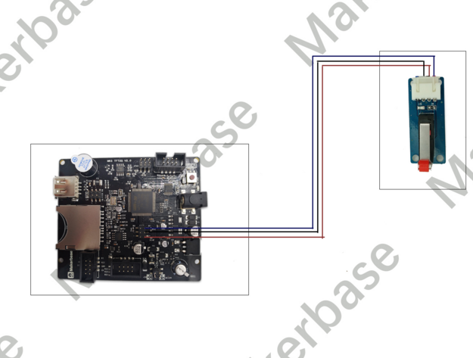

Photo1

**Over-insert or filament falls down to modulre problem**

It is available to set XYZ pause position on firmware to fix this problem.

As following:

